# **CTF Challenge: Ethical Hacking - Using SSL Labs**

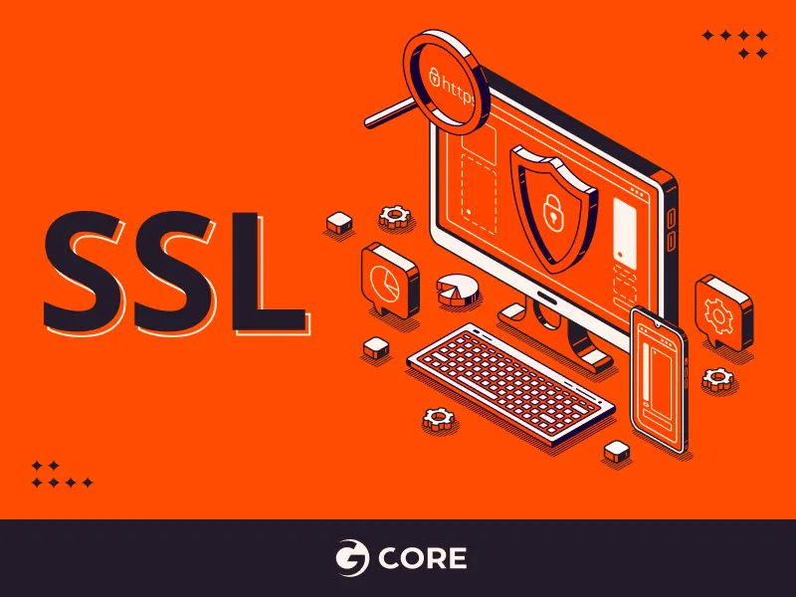

# **1. Introduction**



SSL Labs provides a free online service to perform an in-depth analysis of the c This challenge will introduce you to using SSL Labs to evaluate the security of a target website.

# **2. Tools and requirements**

Access to the Internet and Search for SSL Labs

# **3. Scenario**



As an ethical hacker, your task is to assess the SSL/TLS security of a website using SSL Labs. You'll check their configuration to see how well it protects data transmitted over the internet. SSL Labs gives a rating from A+ to F based on factors like encryption strength and vulnerability to attacks. Your job is to find this rating and report any weaknesses so the site can improve its security.

# **4. Process to follow while performing SSL Labs**

Step 1: Go to Your Browser and search for SSL Labs or click on the link provided:

[**https://www.ssllabs.com/**](https://www.ssllabs.com/)

Step 2: It will open and click on Test your server option and copy the website link provided to you [**http://altoro.testfire.net/**](http://altoro.testfire.net/)solve the CTF.

# **5. Let’s Begin the Challenge**

**Questions**

Flag 1: What is the SSL Labs Overall rating of the website?

Answer: T

Flag Captured

Flag 2: What key is used on the Testfire Website?

Answer: RSA 2048 bits (e 65537)

Flag Captured

Flag 3: What is the Signature Algorithm of the Website?

Answer: SHA256withRSA

Flag Captured

**Hint**

Use the "SSL Test" tool on SSL Labs to perform the analysis.



